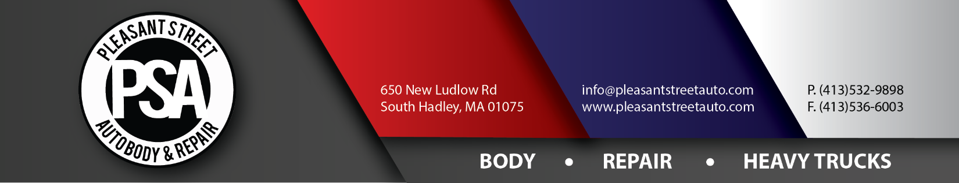
Credit Card Authorization

ATTN: _______________________________________ FROM: ____________________________________________
FAX #: _______________________________________ FAX: ______________________________________________

I hereby authorize charges to be applied to my credit card for expenses incurred to Pleasant Street Auto Body & Repair, Inc. and/or Hampshire Towing.
Please provide the following credit card information:
Type of credit card (please circle one): VISA MASTERCARD DISCOVER
Credit Card Account Number: _________________________________________________________________________
Expiration Date: Month_____________ Year____________ Verification Code (back of card) ___________________
Cardholder Name (Please print clearly!): ________________________________________________________________
City: ________________________ State: ________________________ Zip Code:_______________________________

By way of my signature, I hereby authorize Pleasant Street Auto Body & Repair, Inc. dba Hampshire Towing to collect payment from the aforementioned credit card service on all existing bills incurred to this date.
Signature: ________________________________________________ Date: __________________________________
Please note: A copy of the cardholders’ photo ID as well as the front and back of the aforementioned credit card must accompany this form. This form must be returned to fax number (413)536-6003.
Date of Loss: __________________________ Invoice #: ____________________ Total of Sale: $__________________
PSA/HT Employee: ___________________________________________________ Date: _________________________

