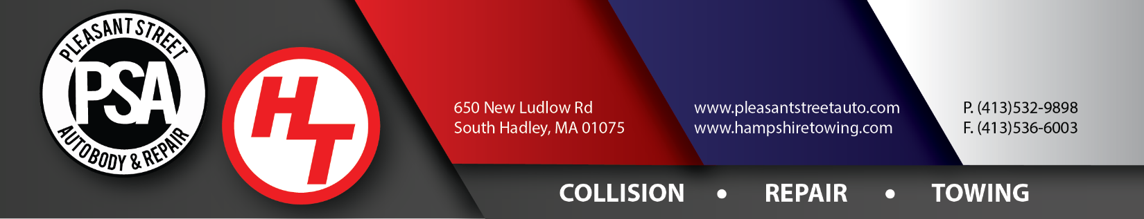
Hold Harmless Agreement – Illicit Discharge

Date: ______/______/______

I, ______________________________________________, of______________________________________, indemnify & hold (PSA) Pleasant Street Auto Body & Repair, Inc. DBA (HT) Hampshire Towing of 650 New Ludlow Road South Hadley harmless of any and all liability arising from releasing my vehicle to me. I understand the vehicle is not drivable and legal to operate on the roads. I also understand the vehicle is leaking fluids (illicit discharge) and illicit discharges are prohibited from the entering the ground water. I have also been advised another towing can remove the vehicle from the impound lot. An Insurance Certificate in the amount of $1,000,000 needs to be obtained or on file for the company to enter our storage lot. If one cannot be obtained we can tow the vehicle to the public area where it can be picked up.

In the event of action from the Department of Environmental Protection or Environmental Protection Agency. A lawsuit or court case, I agree to pay any & all fees/fines including but not limited to attorney fees, court costs and any monies resulting from a judgment associated with such a case.

Signature: ___________________________________________________________ Date: _____/_____/_____

Company Representative: _______________________________________________ Date: _____/_____/_____

VIN: ______________________________________________ Make: __________________________________

--------------------------------------------------------------------------------------------------------------------------------------------------

Invoice/Towbook #: _____________________________________ Employee Name: _____________________

