Insureds Rights: Total Loss Vehicles & Repairable
We at Pleasant Street Auto pride ourselves on giving exceptional customer service. To ensure this, we provide a packet to all of our customers, explaining your rights as it relates to your auto insurance in Massachusetts.
1
Contains a memo from the Division of Insurance stating that an insurance company cannot steer someone from a specific repair shop.

Contains a section of the Massachusetts CMR's (Code of Massachusetts Regulations) which states a vehicle cannot be totaled until it has been inspected and appraised by a Licensed Appraiser. It further states the vehicle owner needs to give permission for the vehicle to be moved.
2

Are from the Division of Insurance web site FAQ (Frequently Asked Questions). The question that pertains to a totaled vehicle is number ten (10) which states the insurance company is responsible for tow and storage until an offer is made as to the value of your automobile. The other questions pertain to the vehicle loss as it relates to your insurance policy.
3-5

Contains a section of the MGL (Massachusetts General Laws) in which every insurance policy in the Commonwealth has (MGL C175 Sec. 191A). This gives you, the insured, the right to dispute, through arbitration, the amount offered on your vehicle.
6

We are giving you this information so you can make an informed decision about the disposition of your vehicle. Pleasant Street Auto (413-532-9898) employs two licensed appraisers who can help you with the repairs, or obtaining a value for your vehicle if it is totaled. Some police departments require a police release, and we require a written release from the vehicle owner to have your vehicle removed from the storage yard. We have the written release policy in place to protect your rights. If you have any questions, please call Pleasant Street Auto at 413-532-9898. We understand that an accident is very upsetting, and we are here to help you with the insurance process.

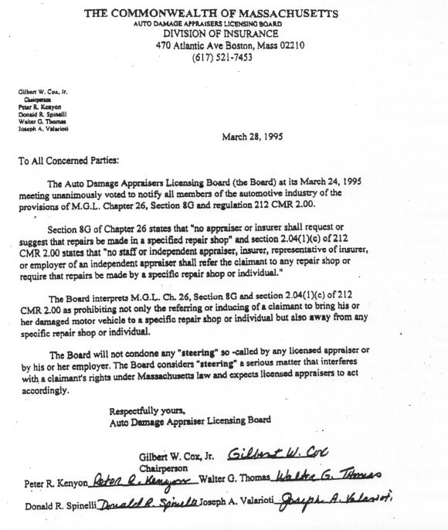
Memo from the Division of Insurance
1

Excerpt of a section of the
Code of Massachusetts Regulations (CMR’s)
2

212 CMR 2.04
CODE OF MASSACHUSETTS REGULATIONS
TITLE 212: AUTO DAMAGE APPRAISERS LICENSING BOARD
CHAPTER 2.00: THE APPRAISAL AND REPAIR OF DAMAGED MOTOR VEHICLES
2.04: Procedures for the Conduct of Appraisals and Intensified Appraisals

f) Determination of Total Loss. Whenever the appraised cost of repair plus the estimated salvage may be reasonably expected to exceed the actual cash value of a vehicle, the insurer may deem that vehicle a total loss. No motor vehicle may be deemed a total loss unless it has been inspected or appraised by a licensed appraiser nor shall any such motor vehicle be moved to a holding area without the consent of the owner. A total loss shall not be determined by the use of any percentage formula.

FAQ – Division of Insurance
3

Frequently Asked Questions on Auto Insurance
The Official Website of the Office of Consumer Affairs & Business Regulations (OCABR)

1) ARE THERE ANY SPECIFIC TIME LIMITS FOR AN INSURANCE COMPANY TO PAY FOR COLLISION OR COMPREHENSIVE CLAIMS?
There are no specific time limits for the settlement of claims. Insurance companies are required by law to pay all claims in a prompt and reasonable amount of time. However, what constitutes "prompt and reasonable" may vary from claim to claim. Claims that require special or extended investigation may take longer to resolve. Inclement weather conditions often cause an increase in the number of claims filed and that can delay the process as well. If, however, the insurance company fails to pay a comprehensive or collision claim within seven days after it receives an official claim form stating that the vehicle has been repaired, the insured may sue for the payments claimed to be due.
2) MY AUTO WAS DECLARED A TOTAL LOSS FOLLOWING AN ACCIDENT. IS MY COMPANY REQUIRED TO GIVE ME THE REPLACEMENT COST?
When your auto is declared a total loss, your insurance company will pay you only the actual cash value of the auto as of the date of the loss, not the cost to replace it. Your auto's value is determined by the following factors: the retail value for an auto of like kind and quality prior to the accident; the price paid for the auto plus the value of prior improvements to the auto at the time of the accident; the decrease in value of the auto resulting from prior unrelated damage which is detected by the appraiser or for which a claim has been paid; and the actual purchase cost of an available auto of like kind and quality.
If your auto has substantial value because of its exceptional condition such as an antique, classic, or restored auto, you should have it appraised and then insure it for the appraised value.
3) DO I HAVE TO PAY AN INSURANCE PREMIUM AFTER MY AUTO IS DECLARED A TOTAL LOSS?
Yes, you must pay an insurance premium even if your auto is declared a total loss until such time that you return your license plates to the Registry of Motor Vehicles. Your auto policy terminates when you return the license plates to the Registry of Motor Vehicles. If you don't have your license plates because your auto was stolen or because your auto and plates were destroyed in a fire, you must go to the nearest Registry of Motor Vehicles office and obtain a lost or stolen plates receipt. This receipt must be presented to your insurance company in order to cancel your policy and avoid paying any additional premium.

4

4) MAY I KEEP MY AUTO IF I HAVE A COLLISION, LIMITED COLLISION OR COMPREHENSIVE CLAIM AND MY INSURANCE COMPANY DECLARES IT A TOTAL LOSS?
Your insurance company has the option to take title to your auto when it issues payment on your claim. The insurer is entitled to any salvage value your auto may have. You can, of course, negotiate with your company to purchase your auto for the agreed salvaged value.
5) THE BODY SHOP IS REPAIRING MY AUTO AFTER AN INSURED LOSS. WILL MY INSURANCE COMPANY PAY FOR ORIGINAL EQUIPMENT MANUFACTURER (OEM) PARTS?
If the repair of the damaged part impairs the operational safety of the auto, the insurance company will pay to replace it with an OEM part. For non-safety parts, unless your claim occurs during the first 20,000 miles on the auto's odometer, you are not entitled to OEM parts. For autos with more than 20,000 miles, state regulation allows for the replacement of damaged parts with used, reconditioned or after-market parts. You can insist on OEM parts, but you will have to pay the difference in cost.
6) AN OBJECT DAMAGED MY WINDSHIELD AND I AM UNABLE TO DETERMINE WHERE IT CAME FROM. AM I COVERED FOR THIS LOSS?
Yes, if you have comprehensive insurance you are covered for the full amount of the loss, unless you opted for a $100 deductible for glass breakage. The $300, $500, or $1000 deductible, or whatever you may have selected for comprehensive coverage, does not apply to a glass loss.
7) CAN MY INSURANCE COMPANY DENY A CLAIM FOR DAMAGES TO MY AUTO IF THE PRINCIPAL PLACE OF GARAGING LISTED ON MY APPLICATION IS FALSE?
Yes. If you or someone on your behalf gives false, deceptive, misleading or incomplete information on any application and if such information increases the insurance company's risk of loss, your company may then refuse to pay claims under any or all of the Optional Insurance coverages of the policy. Such information includes the description and place of garaging of the vehicles to be insured, the names of the operators required to be listed and the answers given for all listed operators. In the event that you have moved since you filled out your initial application, promptly notify your insurance company and the Registry of Motor Vehicles of your new address.
10) WHO IS LIABLE FOR THE STORAGE CHARGES ON MY DAMAGED AUTO WHEN THERE IS A DISPUTE AS TO THE AMOUNT OF THE CLAIM PAYMENT?
The insurance company is responsible for paying storage charges until it makes a reasonable offer to settle the claim. However, if the consumer disputes the amount offered and the company revises its offer, this does not necessarily mean that the original offer was unreasonable. Disputes over what is reasonable can be resolved with your company through the process described in your insurance policy. You can also submit a written complaint to the Division of Insurance if you are unable to settle the dispute.

12) IF I OWN AN AUTO WITH COLLISION AND COMPREHENSIVE COVERAGE, WILL MY INSURANCE APPLY TO A RENTAL OR BORROWED PRIVATE PASSENGER AUTO?
Yes. Your collision and comprehensive insurance coverages are transferable to a substitute rented or borrowed private passenger auto that is damaged while it is being operated by you or members of your household with the consent of the owner. There is no coverage under your policy for family friends or significant others. You should be aware that your coverage is available only if you rent or borrow a private passenger auto in the United States or Canada. You should also be aware that your policy does not provide coverage for a borrowed or rented truck. If you are renting a truck, you should check with the rental company regarding the purchase of collision and comprehensive insurance. If you are borrowing a truck, make sure you determine whether or not the owner has purchased collision or comprehensive coverage. If the owner does not have insurance, you may be personally liable for any damage to that truck which is the result of your negligent operation. If the use is for business rather than pleasure, call your agent first. Business use is usually not covered under your personal auto insurance policy.
5

Section of Mass. General Laws – Insurance Policies
6
PART 1 ADMINISTRATION OF THE GOVERNMENT
TITLE XXII CORPORATIONS
CHAPTER 175 INSURANCE
SECTION 191A PROPERTY DAMAGE TO INSUREDS MOTOR VEHICLE; NOTICE OF LOSSES; ARBITRATION CLAUSE
Section 191A. No company shall issue a policy or contract which insures against physical damage to a motor vehicle of the insured unless said policy contains in substance the following provisions:—
In case of any loss or damage insured against under the policy, the named insured shall give notice thereof as soon as practicable to the company or any of its authorized agents and also, in the event of larceny, robbery or pilferage, to the police, and within sixty days after filing proof of loss the company shall pay the amount of loss as provided in the policy.
If the named insured and the company fail to agree as to the amount of loss, each shall, on the written demand of either, made within sixty days after receipt of proof of loss by the company, select a competent and disinterested appraiser, and the appraisal shall be made at a reasonable time and place. The appraisers shall first select a competent and disinterested umpire, and failing for fifteen days to agree upon such umpire, then, on the request of the named insured or the company, such umpire shall be selected by a judge of a court of record in the county and state in which such appraisal is pending. The appraisers shall then appraise the loss, stating separately the actual cash value at the time of loss and the amount of loss, and failing to agree shall submit their differences to the umpire. An award in writing of any two shall determine the amount of loss. The named insured and the company shall each pay his or its chosen appraiser and shall bear equally the other expenses of the appraisal and umpire.
The company shall not be held to have waived any of its rights by any act relating to appraisal.

